2) Using Form Tags,
2.1) Create a Login Form
<html>
<head>
<title> Login form </title>
<body bgcolor="lavender" >
<center>
<h1> LOGIN FORM </h1>
</center>
<form>
<label for="name">Enter username</label><br>
<input type="text" id="name" name="name"><br>
<label for="pass">Enter Password</label><br>
<input type="Password" id="pass" name="pass"><br>
<input type="submit" value="submit">
<input type="checkbox" checked="checked"> Remember me
<button type="button" class="cancelbtn"> Cancel</button>
Forgot <a href="#"> password? </a>
</form>
</body>
</html>
OUTPUT:
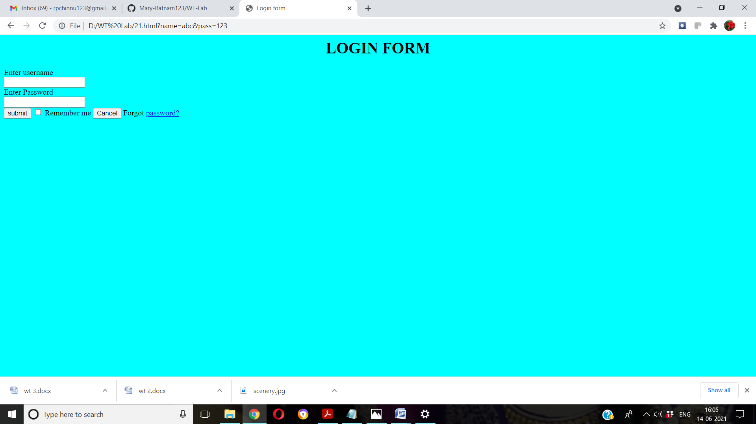

2.2) Create a “Registration form” with the following fields
a) Name (Text field)
b) Password (password field)
c) E-mail id (text field)
d) Phone number (text field)
e) Sex (radio button)
f) Date of birth (3 select boxes)
g) Languages known (check boxes – English, Telugu, Hindi, Tamil)
h) Address (text area)

<html>
<head>
<title> Registration Form </title>
</head>
<body>
<center>
<h1> REGISTRATION FORM </h1>
<form>
<table style="border:1px solid" bgcolor="lavender">
<tr>
<td><label>Name</label></td>
<td><input type="text" id="name" name="name" size="15"></td>
</tr>
<tr>
<td><label>Password</label></td>
<td><input type="Password"></td>
<td><input="Password" id="pass" name="pass"></td>
</tr>
<tr>
<td><label>E-Mail</label></td>
<td><input type="email" id="email" name="email"></td>
</tr>
<tr>
<td><label>Phone Number</label></td>
<td>
<input type="text" name="country code" value="+91" size="2"/>
<input type="text" name="phone" size="10"/>
</td>
</tr>
<tr>
<td><label>Gender</label></td><br>
<td>
<input type="radio" name="male"/>Male<br>
<input type="radio" name="female"/>Female<br>
<input type="radio" name="other"/>Other<br><br>
</td>
</tr>
<tr>
<td><label>Date of Birth</label></td>
<td><input type="date" name="dob"/></td>
</tr>
<tr>
<td><label>Languages Known</label></td><br>
<td>
<input type="checkbox" id="language1" name="language1" value="English">
<label for="language1"> English </label><br>
<input type="checkbox" id="language2" name="language2" value="Telugu">
<label for="language2"> Telugu </label><br>
<input type="checkbox" id="language3" name="language3" value="Hindi">
<label for="language3"> Hindi </label><br>
<input type="checkbox" id="language4" name="language4" value="Tamil">
<label for="language4"> Tamil </label><br><br>
</td>
</tr>
<tr>
<td><label>Address </label></td><br>
<td><textarea cols="80" rows="5" value="address"></textarea></td>
</tr>
<tr>
<td><center><button type="submit" class="registerbtn">Register</button></center></td>
</tr>
<tr>
<td><center><button type="reset" class="resetbn">Reset</button></center></td>
</center>
</tr>
</center>

OUTPUT:
